# LockedMe Project submission By

# Darshan H Jethwa

Date of Submission: 04-september-2022

Source Code GitHub Link:

<https://github.com/darshan-jethwa/Phase1_project_LockedMe>

# Screen Shots of LockedMe Project

**1. Welcome Screen :**

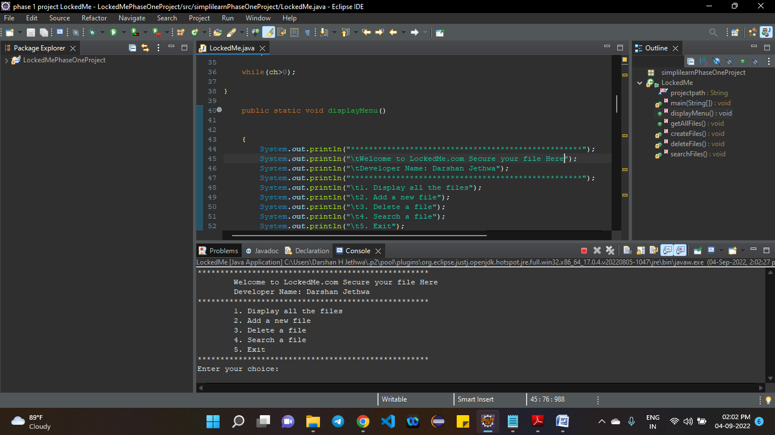

**2. Getting All Files :**

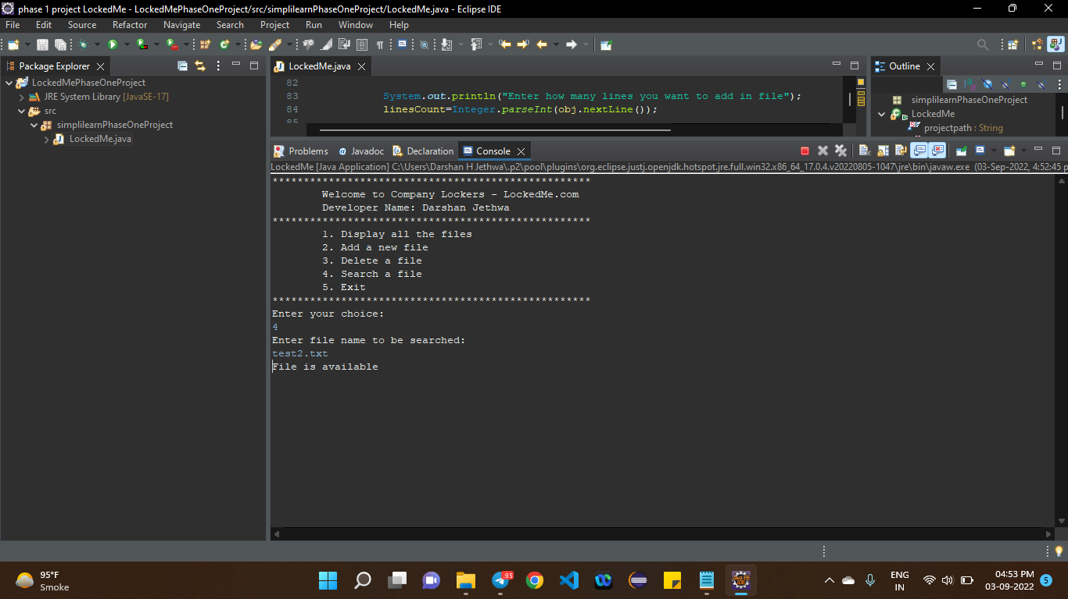

Figure 1 when file exist in file path

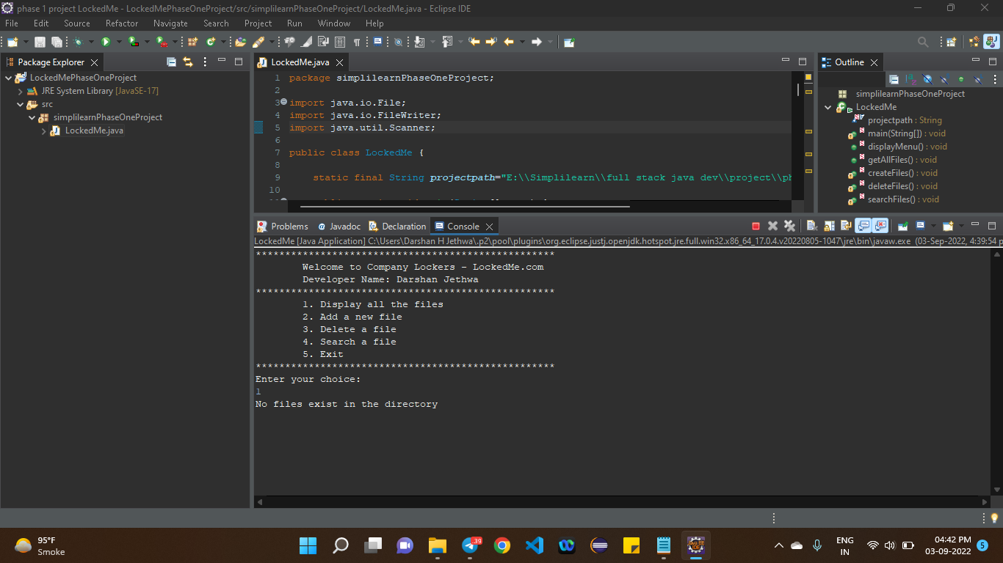

Figure 2 when file does not exist in file path

**3. Add new file :**

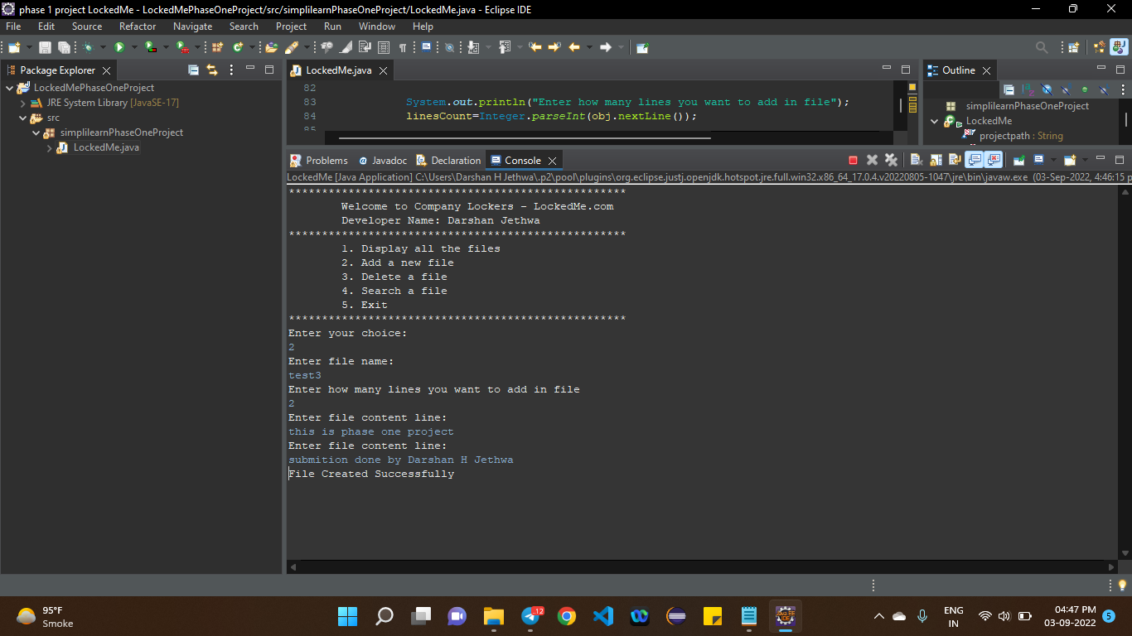

Figure 3 Add new file

**4. Delete a file:**

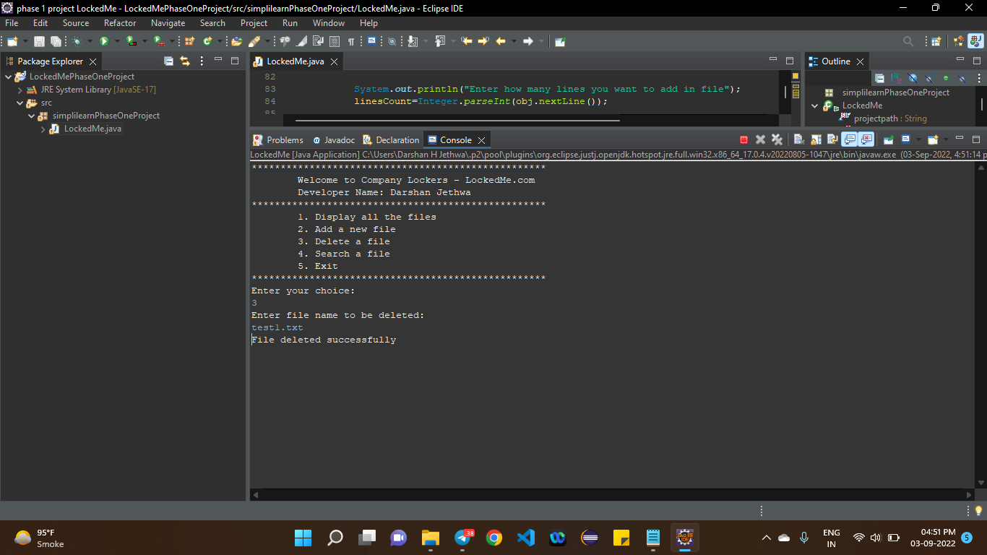

Figure 4 delete a file

**5. Search file:**



Figure 5 search result when file available

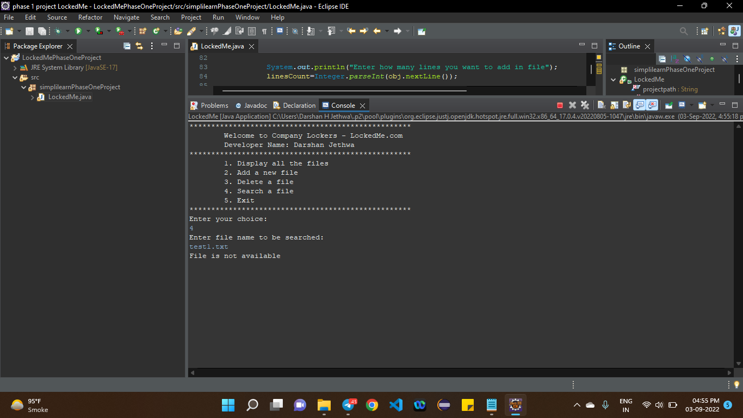

Figure 6 search result when file not available

**6. Exit:**

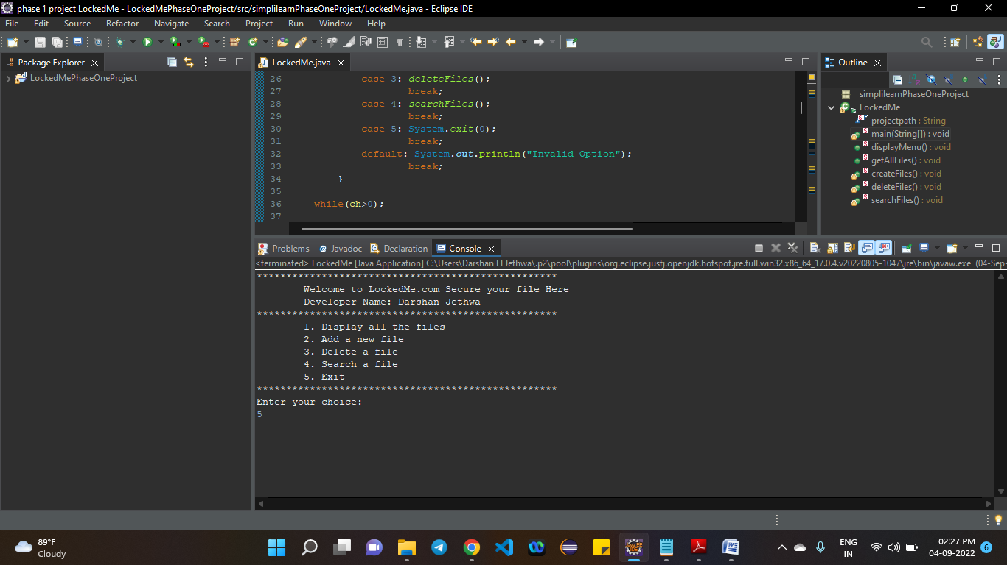

Figure 7 exit from app

# Thank You

**Simplilearn Phase 1 Project**

**Submission by**

**Darshan H. Jethwa**